**Sikuli**

Sikuli is a powerful tool for automating GUI testing and interactions by using image recognition. It can be particularly useful for object testing where traditional automated testing tools fall short, especially in situations involving non-standard GUI elements or graphical applications.

Setting Up Sikuli for Java

**Install Sikuli:** Download and set up Sikuli from the official website.

**Add Sikuli Libraries to Your Project:**

Download the Sikuli API JAR file (sikulixapi.jar) and add it to your project's classpath.

If you're using Maven, you might need to manually add the local JAR file to your repository.

Example of Object Testing Using Sikuli in Java

**Dependencies**

Since Sikuli does not have an official Maven repository, you'll need to manually add the sikulixapi.jar to your project.

**Example Code**

Here's an example of how to use Sikuli for object testing:

**Initial Setup:**

Ensure SikuliX is correctly set up and sikulixapi.jar is added to your classpath.

Create images (screenshots) of the GUI elements you want to interact with. These images will be used as patterns for Sikuli to recognize and interact with.

**Write the Test Code:**

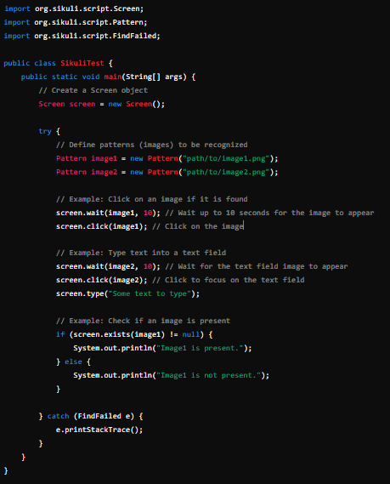

**Key Concepts in Sikuli**

**Screen:** Represents the entire screen or a specific monitor.

**Pattern:** Represents an image pattern that Sikuli will search for on the screen.

**FindFailed:** Exception thrown when Sikuli fails to find the specified pattern on the screen.

**Steps for Using Sikuli**

**Capture Images:** Take screenshots of the GUI elements you want to interact with. Save these images in a directory accessible by your test code.

**Define Patterns:** Use the Pattern class to define these images in your code.

**Perform Actions:** Use methods like click(), type(), exists(), and wait() to interact with the GUI elements.

**Example Scenarios for Sikuli Testing**

**Login Form Testing:**

Capture images of the username field, password field, and login button.

Use Sikuli to enter text into the fields and click the login button.

**Button Click Testing:**

Capture an image of the button.

Use Sikuli to click the button and verify the expected outcome (e.g., a new window or dialog appears).

**Validation Message Testing:**

Capture an image of the validation message.

Use Sikuli to verify that the message appears under certain conditions.

**Conclusion**

Sikuli is a versatile tool for GUI testing using image recognition. It can be particularly effective for testing applications with complex or custom GUI elements where traditional automated testing tools might struggle. By using Sikuli with Java, you can automate interactions and verifications based on the visual appearance of elements, providing a robust solution for end-to-end testing of graphical applications.